

DEPARTMENT OF MATHEMATICS
NATIONAL SCIENCE DAY 2026
DATE: 28 -02-2026

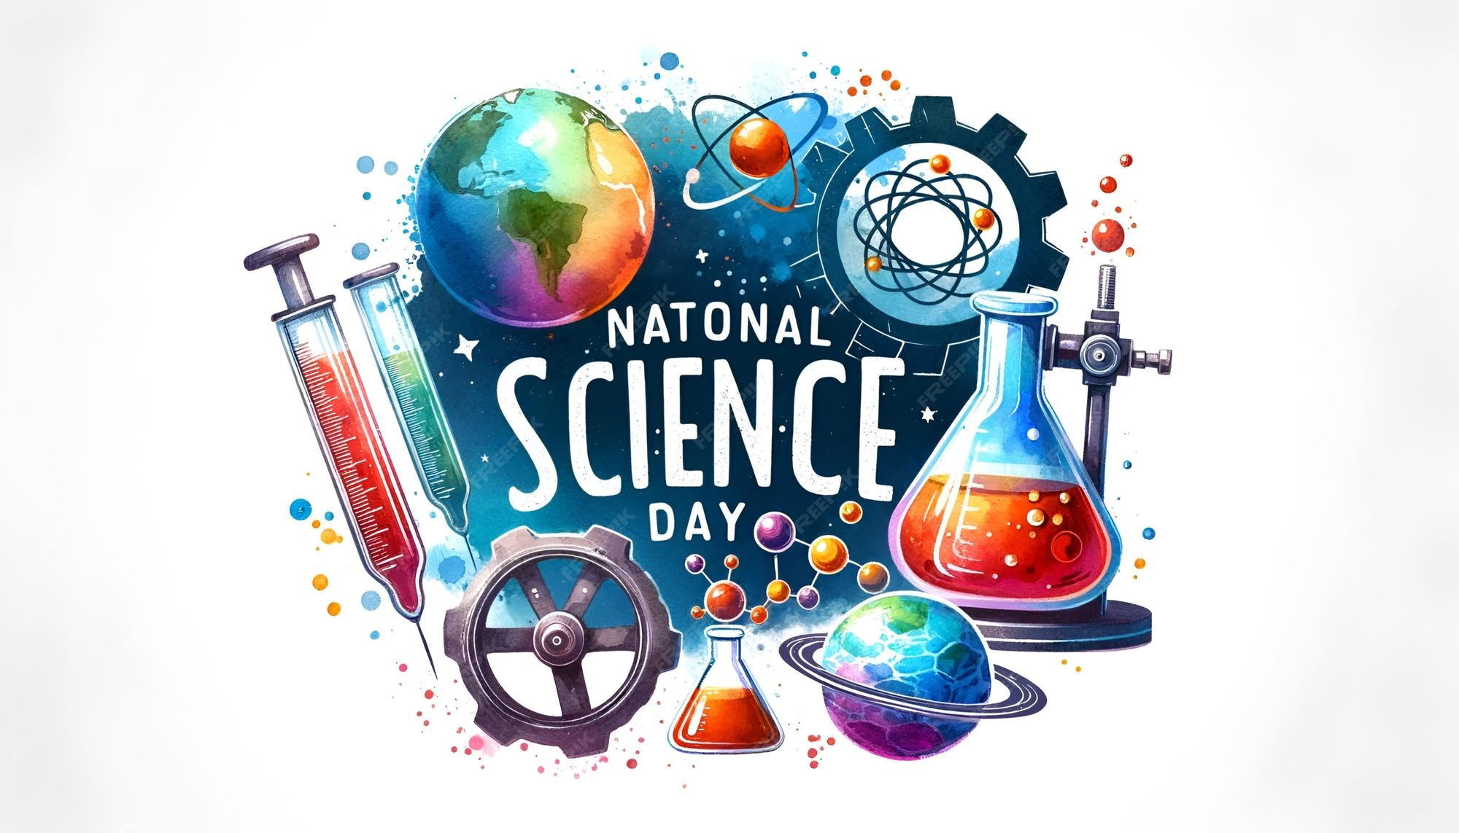

CIRCULAR

Date: 20 February 2026
To
The Principal
MJPTBCWRDC Women, Station Ghanpur
Subject: Request for Permission to Conduct National Science Day Program for the Academic Year 2025-2026
Respected Madam,
With reference to the above-mentioned subject, we would like to submit a proposal to conduct a National Science Day Program on 28 February 2026 as part of our academic activities.
National Science Day is celebrated to commemorate the discovery of the Raman Effect by Sir C. V. Raman. The theme for National Science Day 2026 is “Empowering Indian Youth for Global Leadership in Science and Innovation.” On this occasion, the department proposes to organize activities such as seminars, science exhibitions, and quiz competitions to promote scientific awareness among students.
We kindly request your permission to approve our proposal for organizing this program. We believe that this initiative will help enhance students’ scientific knowledge and encourage their active participation in innovative learning.
Thank you for your time and consideration.
Yours faithfully
HOD
Department of Science
MJPTBCWRDC Women, Station Ghanpur

CIRCULAR

CIRCULAR

Subject: Celebration of National Science Day – 2026
National Science Day will be celebrated in our college on 28 February 2026 to commemorate the discovery of the Raman Effect by Sir C. V. Raman. The theme for National Science Day 2026 is “Empowering Indian Youth for Global Leadership in Science and Innovation.”
On this occasion, the Department of Science will organize various activities such as Science Quiz, Poster Presentation, Seminar, and Science Exhibition to promote scientific awareness and encourage innovative thinking among students.
All the students and staff members are requested to actively participate and make the program a grand success.
Date of Program: 28 February 2026
Venue: College Campus
Time: 10:30 AM
Coordinator
Department of Science
Principal
MJPTBCWRDC (W), Station Ghanpur

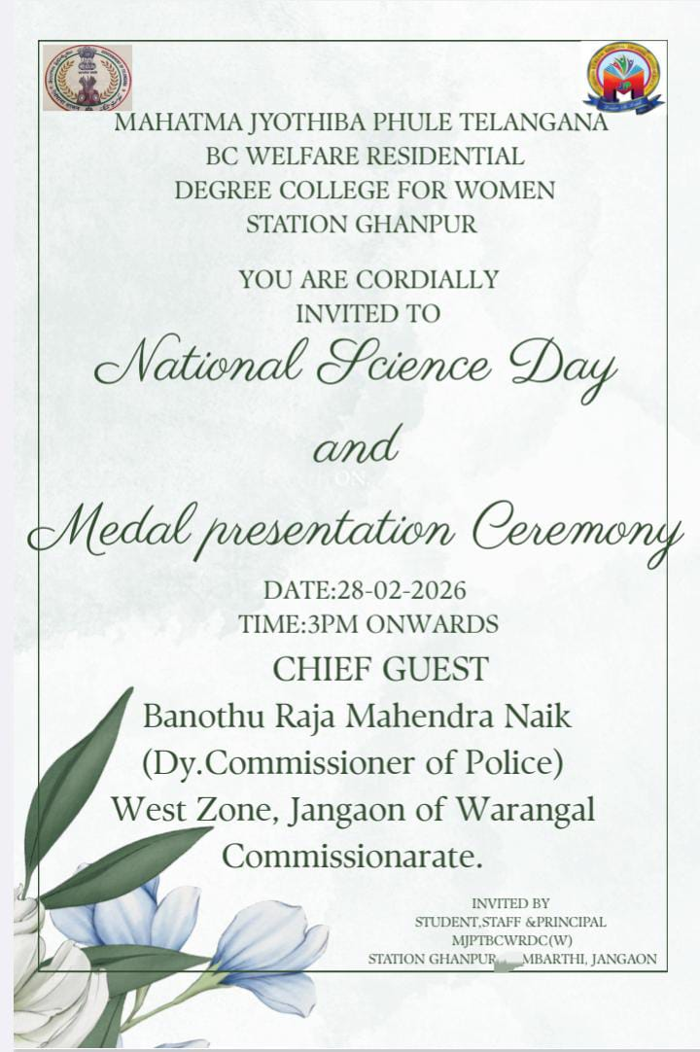
National Science Day 2026 – Brief Report
- Rangoli Competition
A Rangoli competition was organized where students creatively presented science-related themes using colours and designs. The activity encouraged artistic expression while spreading awareness about science concepts.

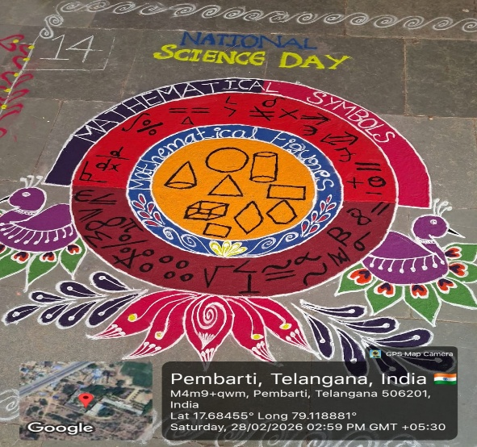
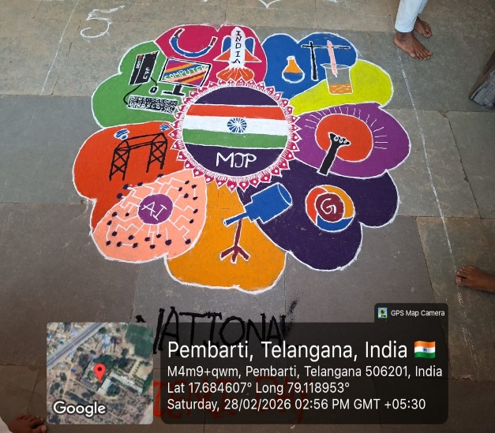

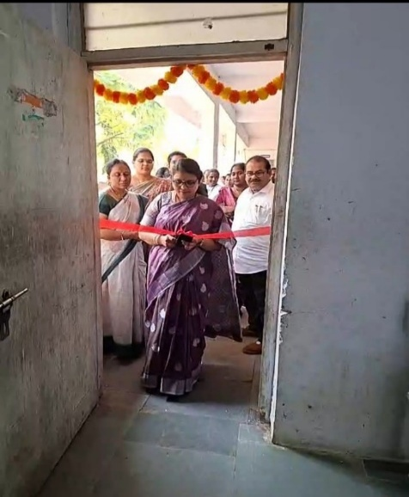
2.Inauguration of All Presentations
The event began with the formal inauguration of all presentations by the principal , chief guests and faculty members. They encouraged students to explore science with curiosity and innovation.

3.Poster Presentations:
Students have actively participated in poster presentation on event of national science day. students have done various poster presentation on importance of mathematics in science and technology field. There was a brief content on various topics. Students presented the poster in innovative way.
The topics of poster presentation are
- Applications of differential equations in carbon dating.
In carbon dating, differential equations are used to model the radioactive decay of the carbon-14 isotope. A first order ordinary differential equation is the standard mathematical tool for estimating the age of organic remains.
The core application begins with the differential equation representing the rate of change of the radioactive substance:$\frac{dN}{dt}$=-kN
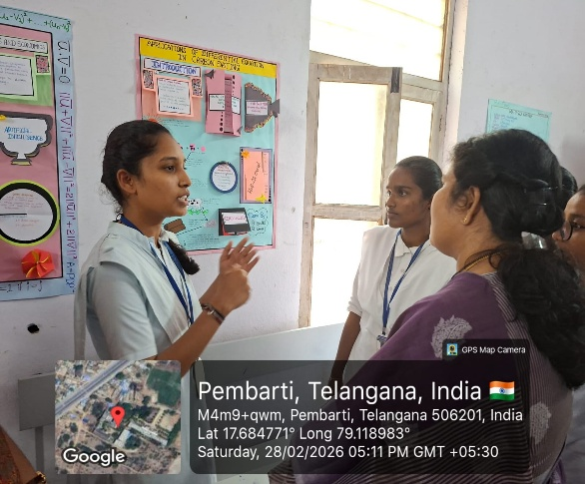
- Applications of differential equations in compound interest:

Differential equations are primarily used to model continuous compound interest.
The fundamental application is representing the rate of change of an investment. If A(t) is the amount of money at time t and r is the annual interest rate, the growth is modelled by first order differential equation: $\frac{dA}{dt}$=rA
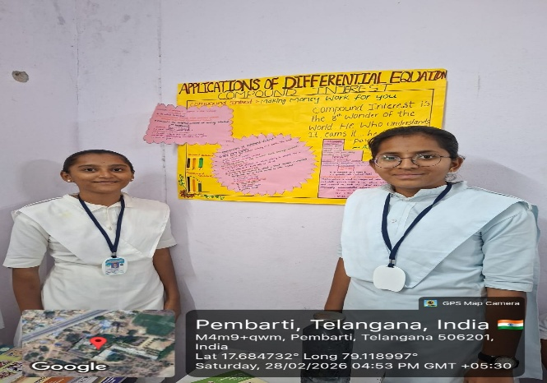
- Applications of differential equations in tumour growth.

Differential equations are the primary tool for modelling complex, time-dependent dynamics of tumour growth and treatment.
Basic models use first order differential equation to describe the change in tumor volume (V) over time (t).
- Exponential model
- Logistic model
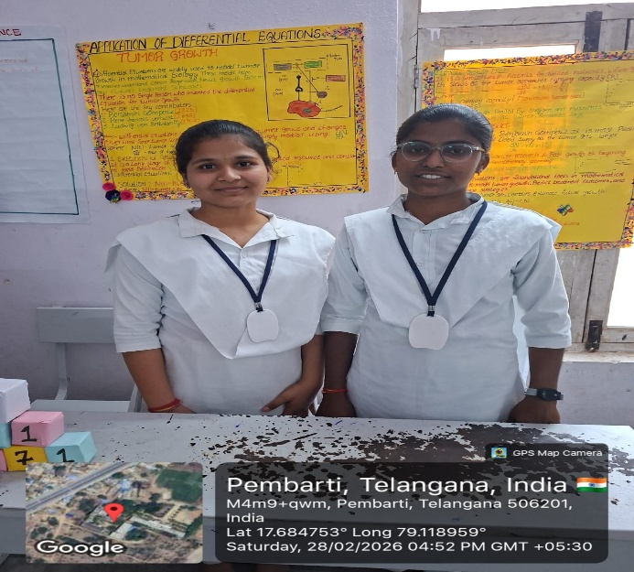

- Applications of differential equation in radioactive decay.

The primary application of differential equations in radioactive decay is to model the rate at which a substance decomposes over time.
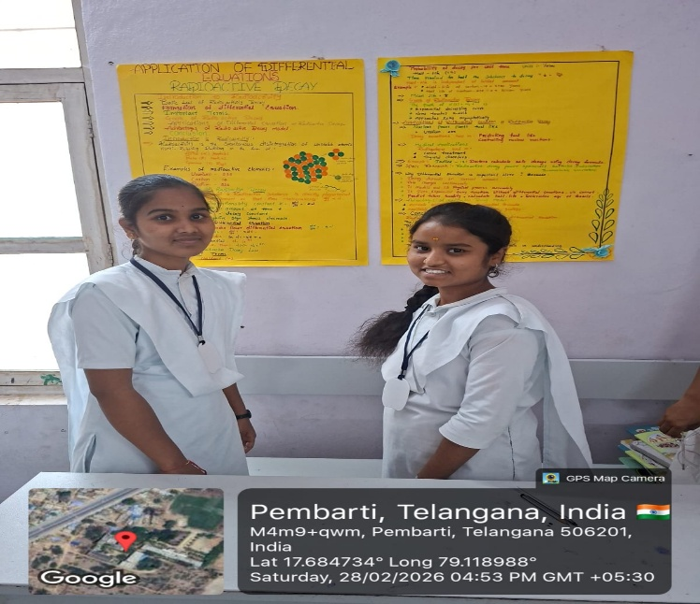

- Applications of differential equations in growth and decay.

Differential equations are used to model situations where the rate of change of a quantity is proportional to the quantity itself. This is expressed by the first order differential equation.
$\frac{dy}{dt}$=Ky , where y is the quantity, t is time, and k is the proportionality constant.
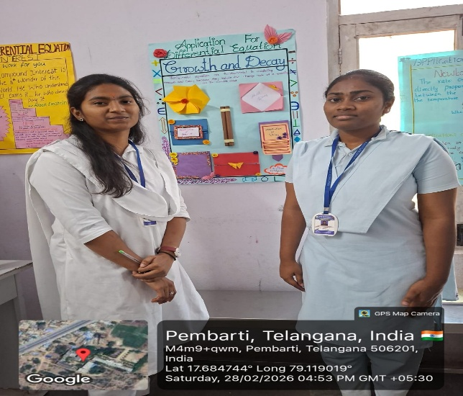

- Applications of linear algebra.
linear algebra is the mathematical engine behind modern technology, by representing data as vectors and operations as matrices, it allows computers to solve complex, high-dimensional problems efficiently.
Core technology applications :
- Computer science and AI
- Search engine
- Computer graphics and gaming
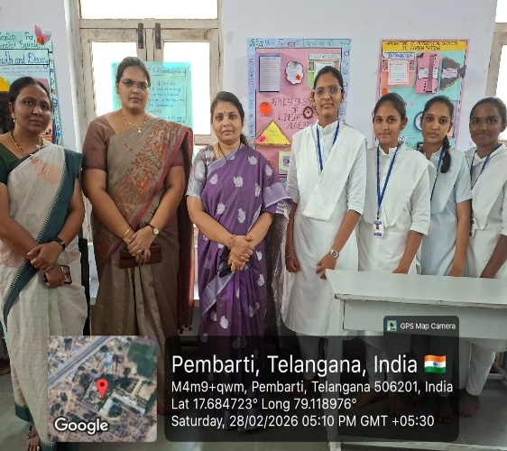
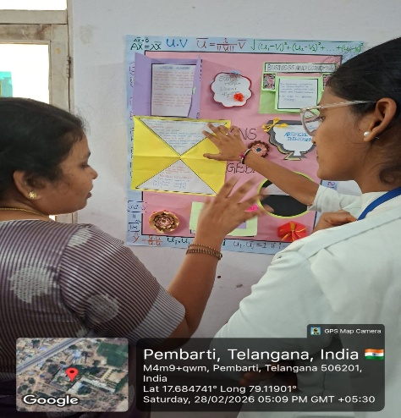
4) Lighting of the Lamp (Lamp Lightening Ceremony)
The program began with the ceremonial lighting of the lamp by the chief guests and faculty members. This symbolized the spreading of knowledge, wisdom, and scientific thinking among students.
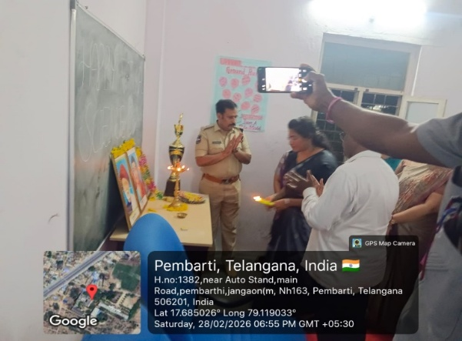

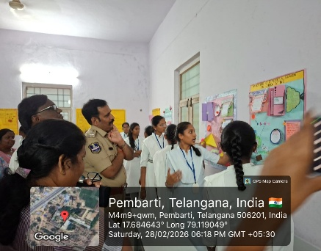
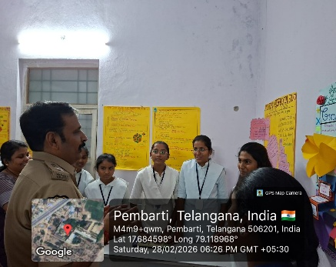
Our chief guest has visited the poster presentation and listened them carefully and questioned them about the subject.
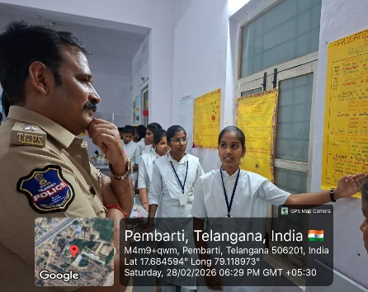
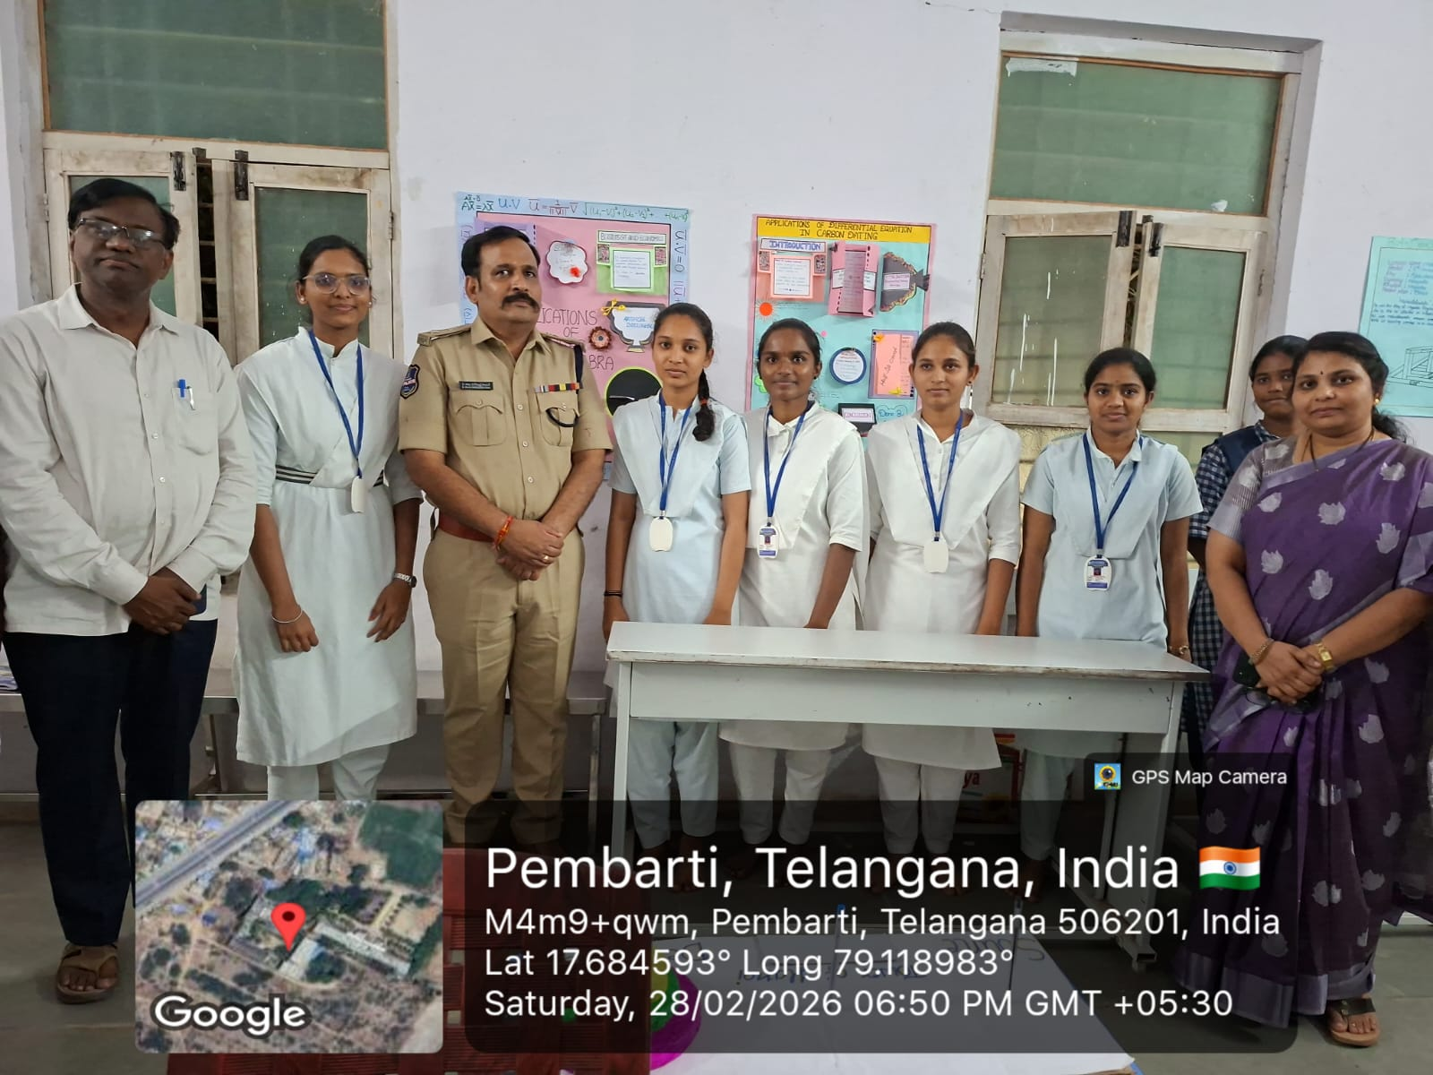
5) PPT on Road Safety Rules by DCP Raja Mahendra Naik Sir
DCP Raja Mahendra Naik Sir presented an informative PPT on Road Safety Rules. He explained the importance of traffic discipline and safety measures to prevent accidents.
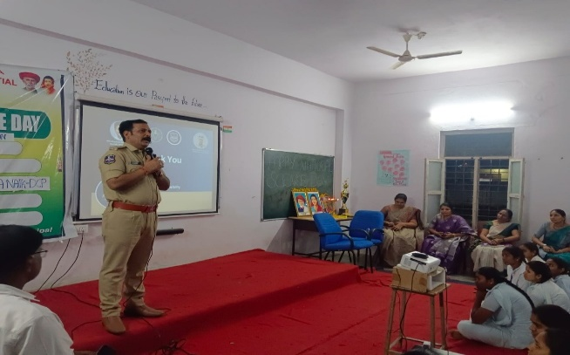
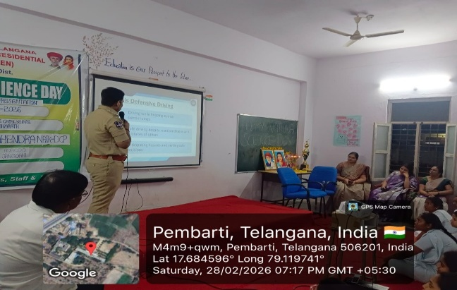

6)Speech by District BC Welfare Development Officer Ravinder Sir
District BC Welfare Development Officer Ravinder Sir delivered an inspiring speech to the students. He motivated them to focus on education, innovation, and the importance of science in daily life.
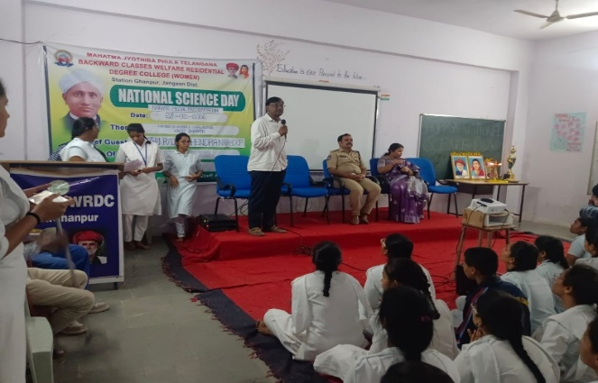

7)Karate Medal Presentation Ceremony
A special Karate Medal Presentation Ceremony was conducted to honour students who achieved success in karate competitions. The medals were presented by the chief guests, appreciating the students’ discipline, strength, and dedication.

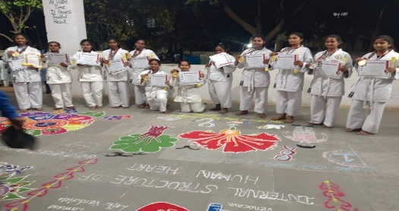

8)Prize Distribution
Prizes were distributed to the winners of various competitions by the chief guests. The winners were appreciated for their talent, effort, and active participation.
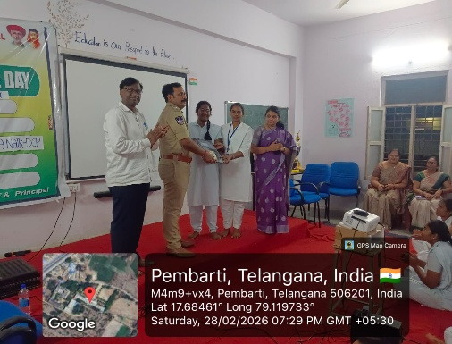
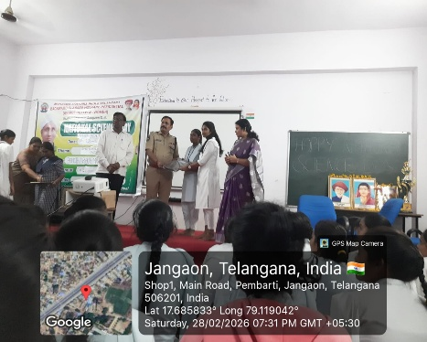
9) Felicitation of the Guests
The chief guests were honoured with shawls and mementos as a mark of respect and gratitude. The felicitation recognized their valuable presence and encouragement to the students.
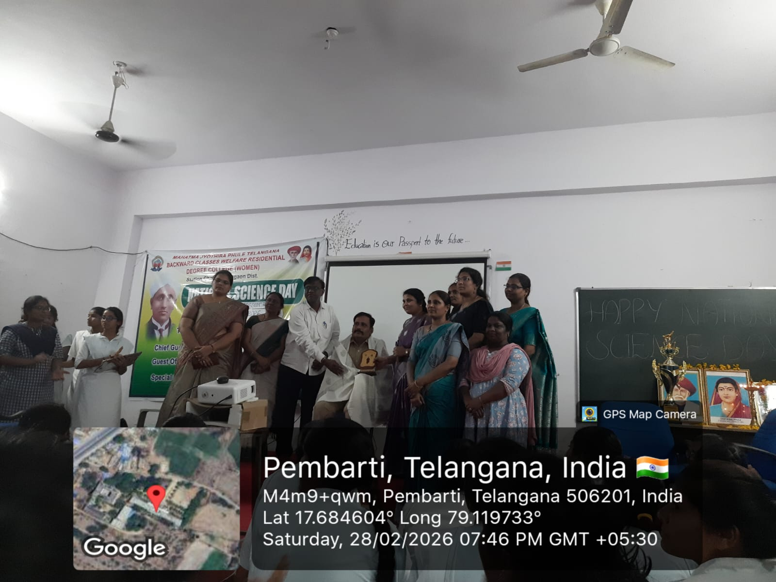

10) Vote of Thanks by Indra Jyothi Mam
The program concluded with a Vote of Thanks delivered by Indra Jyothi Mam. She expressed gratitude to the chief guests, teachers, organizers, and students for making the event successful.

